EXP NO:01 DATE:
DESIGN OF SINGLE-STAGE COMMON- EMITTER AMPLIFIER USING LT SPICE
AIM
To design and simulate a single-stage common-emitter amplifier using a transistor in LT spice, and to analyse its frequency response to determine the voltage gain and bandwidth
SOFTWARE REQUIRED
- LTSpice Simulator
SOFTWARE DESCRIPTION
LTspice is completely free with no feature restrictions, making it accessible for students, hobbyists, and professionals alike.Built on the SPICE simulation engine, it provides precise analog circuit simulation including transient, AC, DC sweep, and noise analyses.. Comes with a vast library of passive components, semiconductors (like BJTs, FETs, op-amps), and Analog Devices IC models.
Users can import 3rd-party models or create custom subcircuits and include them using .include and.lib directives. Allows intuitive schematic creation using drag-and-drop components and easy wiring tools. Includes a built-in waveform viewer with support for math operations, cursors, FFT, and differential measurements. LTspice is widely adopted in education for teaching electronics and in industry for circuit design, saving time and cost before physical prototyping.
THEORY
A common emitter amplifier is type of BJT amplifier which increases the voltage level of the applied input signal Vin at output of collector. The CE amplifier typically has a relatively high input resistance (1 - 10 KΩ) and a fairly high output resistance. Therefore it is generally used to drive medium to high resistance loads. It is typically used in applications where a small voltage signal needs to be amplified to a large voltage signal as in radio receivers.
The input signal Vin is applied to base emitter junction of the transistor and amplifier output Vo is taken across collector terminal. Transistor is maintained at the active region by using the resistors R1, R2 and Rc. A very small change in base current produces a much larger change in collector current. The output Vo of the common emitter amplifier is 180 degrees out of phase with the applied the input signal Vin.

DESIGN
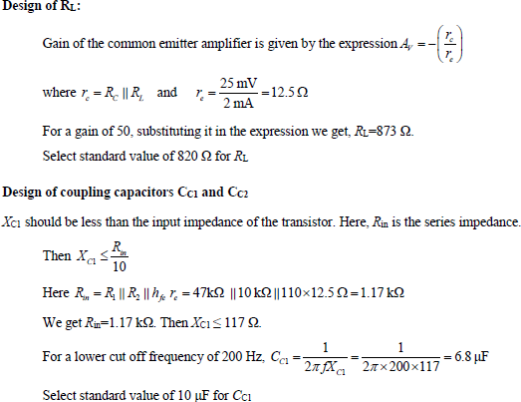
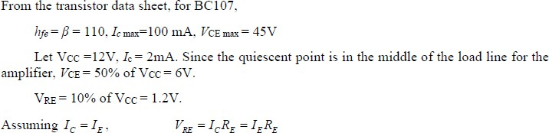
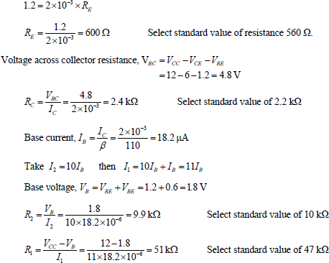

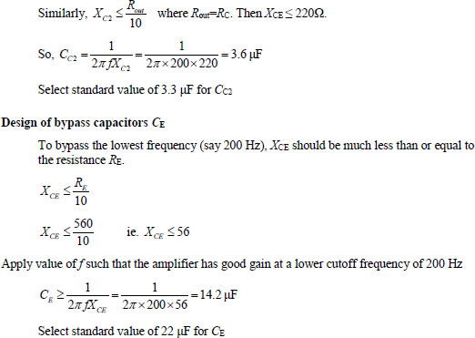

FREQUENCY RESPONSE
The gain of an ideal amplifier should remain the same for any frequency of the input signal. Therefore, the frequency response curve (gain in db plotted against frequency) becomes a straight line parallel to the frequency axis.In actual practice, the coupling capacitors and the emitter bypass capacitor reduce the gain at lower frequencies. The capacitance internal to the transistor and stray capacitance due to the wiring reduce the gain at higher frequencies.
Fig 2 shows the typical frequency response characteristics of CE amplifier. The curve is flat only for middle range of frequencies. There is one low frequency F_{L} and one high frequency F_{H} beyond which the gains, AL and AH are 1/√2 times the gain AM (maximum gain) at the middle frequencies. The two frequencies are called lower and higher cut off frequencies. The difference between them is called the bandwidth.

PROCEDURE:

- Open LTspice and Create a New Schematic
- Place the Circuit Components
- Wire the Components
- Set Component Values
- Add a Simulation Command
- Place the Simulation Command on the Schematic
- Run the Simulation
- Analyze the Results

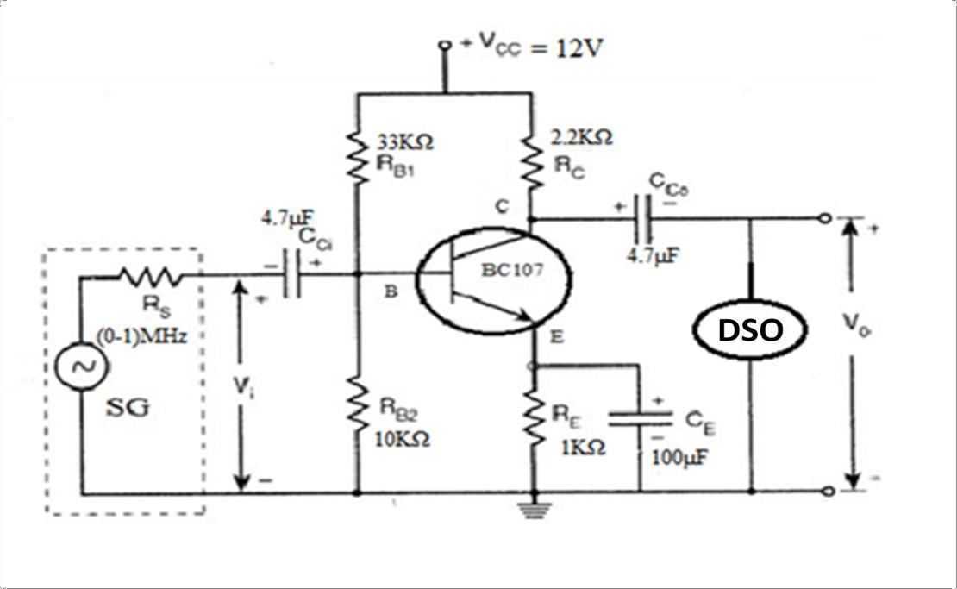
CIRCUIT DIAAM
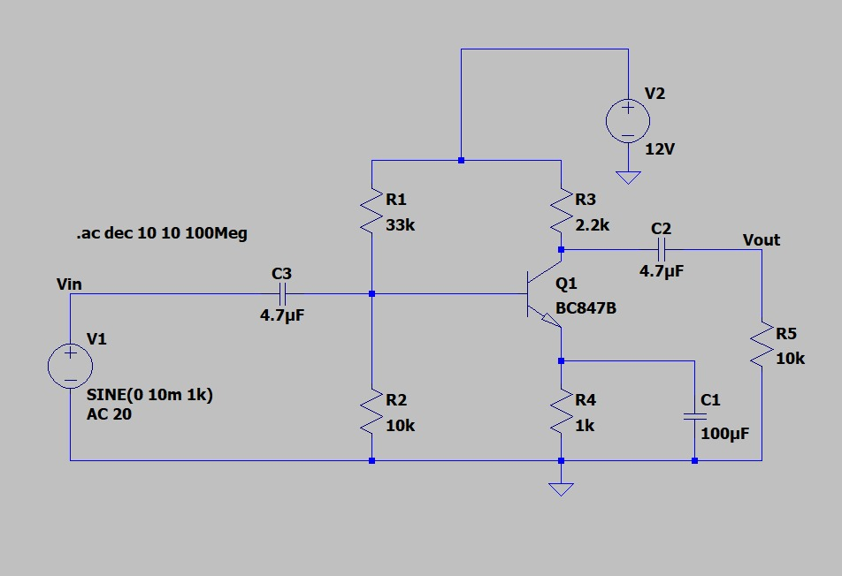

MODEL GRAPH
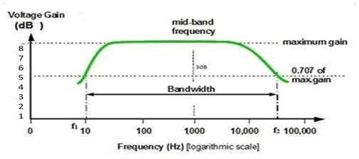
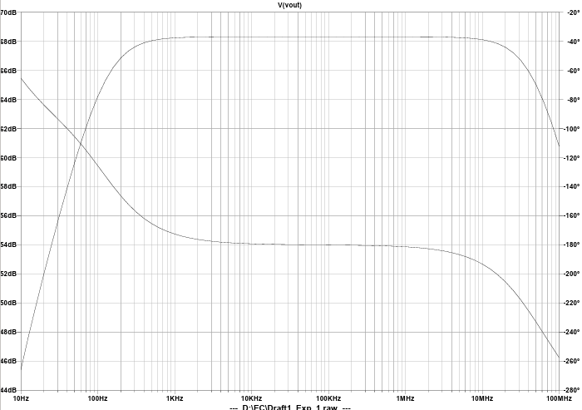

RESULT:

The Common Emitter Amplifier was constructed and the following results were observed.
  - Gain of the amplifier dB
  - Bandwidth of the amplifier Hz
  - Gain –Bandwidth Product -------------------------

